Georgia State Service Assembly
Virtual Business Meeting Minutes
Sunday September 20, 2020
Pending Approval at the January 2021 BUSINESS MEETING
Rick M., Area 16 Chairperson
Moment of Silence followed by the Serenity Prayer
Welcome to our second Virtual Business Meeting
An overview with a slides were given to familiarize attendees with basic Zoom controls and voting procedures.
Several practice polls were done to familiarize participants with the process.
Rick explained how the Third Legacy voting procedure works.
Proxy Voting
Rick explained that our Service Manual states that Proxy votes will not be accepted at the Assembly. The Office Committee recognized that during these times with us meeting virtually, some of our members did not have access to virtual devices. In order to make it possible for those members to have an opportunity to be heard it was decided that we would reach out to our groups to see if there were any that could not participate due to lack of internet access or devices. We received back that one group that fell in that category.
I as your Chair am asking you as a body to vote for this one Assembly to allow that group to be represented by a Proxy.
I will pull up the poll again. We are looking for two thirds because it is a manual issue. The Proxy voting poll was pulled up.
Would you allow Proxy voting for this Assembly only?
Votes were cast
Rick asked that Christy our Area Treasurer and Harold, Past Area Treasurer give us what was required based on the total number of votes for a two thirds majority.
Christy- For two thirds we needed 111. 168 people voted. So, the motion passed.
Yes 156
No 12
Harold confirmed the results.
Rick asked that with any questions except around specific topics we wait until Discussion is called or in General Sharing.

Delegate’s Sharing

Good morning, my name is Debi Keane and I am alcoholic. It is an honor to serve as Delegate for Area 16 as a member of the Pandemic Panel 70 Pioneers. It is good to see all your faces here this morning. These are unprecedented times, but it warms my heart to see the work of Alcoholics Anonymous continue! Thank you for all you do to continue to carry the message of hope and recovery!

I recently read an article on how some of the world’s top spiritual leaders maintain their spiritual connection during this challenging time. They recommended four practices: self-reflection, connecting to community, focusing on the positive, and practicing self-care. This made me think about what we do when we stay in the 12 steps of Alcoholics Anonymous.
Spending more time in inner reflection: isn’t this something we do in steps 4-7, 10 and 11?

Another practice it to connect to the community in new ways. I don’t know about you, but I’ve been able to attend more AA meetings now than I did when we were meeting face-to-face. I have been to meetings all over the United States and a few overseas in Ireland and England. The message of AA is shared across the internet! I can connect with a broader community of recovering alcoholics.

Focusing on the positive- I do this in Step 11 when I get myself spiritually centered. I also practice gratitude in my daily life.

Practicing self-care- We know we must share our journey in recovery to grow and stay sober ourselves. We can’t give away what we don’t have, and we have to keep our own house in order. It is important for us to focus on our own program of recovery, to remain focused on our steps so we can continue to grow.

I am so grateful to have this program of recovery to carry me through these challenging times. I really do not know where I would be without it.

We have not had the opportunity to connect face to face since our January 2020 Assembly. I miss seeing you and hearing about how you are doing and what is happening in your groups!
In order to keep in touch, I am going to start a monthly Zoom meeting. All members are welcome! We will meet virtually on Zoom the first Wednesday of the month at 7:00 PM starting October 7th for an hour to chat. I can provide updates from the Area and GSO. You can pose questions or share information on your districts and groups. The format will be very informal. Zoom ID 930 5601 7418 PW: Coffee
I am looking forward to seeing you! Bring your coffee and your questions!

I wanted to give you an update on the work we have been doing behind the scenes to move forward in implementing the action steps from the Your Voice Matters Action Plan presented at the May Assembly.
Yesterday, at the DCM meeting, I presented the idea and recruited volunteers to serve as cluster chairs to support first-year DCMs and reach out to dark districts. I will be meeting with them over the next few weeks.

The Web committee, under the guidance of the Communications Committee, is beginning the work of planning our website redesign.

We are in the process of transitioning from the 1:1 email system to GSuite. This should be completed in the near future and will increase accessibility to email communication for our DCMs.

Our Committee chairs, including PICPC/Treatment/Corrections/Archives/Grapevine have been seeking input from those who serve as local committee reps to update their email databases. The purpose of these email data bases is to be able to communicate efficiently and share important information. They have also been developing data bases to include professionals who support our outreach.

Rick M, Past Delegate, has prepared content for a DCM Workshop to begin at the January 2021 Assembly.

The Office Committee has held monthly Office Committee meetings on Zoom since the pandemic began. We also hosted the DCM Preconference Meeting, a DCM meeting, meeting with our Committee Chairs and Cochairs, Budget and Finance Committee meetings, and two Area Assemblies using the video-conferencing platform.

As with everything we do in Alcoholics Anonymous, it takes all of us. You can help to implement the actions recommended by our fellow members. These are initiatives we all felt were important.

Communicate- let the state office and your Intergroup know when you have changed your meeting time/location/format. We do post Zoom IDs and PWs on our website.

Update information on the committee reps in your district and groups. This will help our Chairs/Cochairs know who to contact when someone needs help or we need to share important information.

Host more speaker meetings in your home groups to leverage our great history of storytelling.

Our General Service Office (New York) employees have been busy providing AA Services from remote access. AAWS is continuing to process literature orders. Our GSO employees are hoping to be able to return to the General Service Office at the end of September.

The next group of slides are updates from the GSB weekend held in August. I will also provide the FINAL 2019 financials after the Audit was completed later in the presentation.

Sister Judith Ann Karam, Class A Trustee on the GSB, will fill the NTD spot that was vacant. She is not the first Class A to be a director on the AAWS board-but the first in about half a century.

Sister Judith Ann will be presenting a workshop entitled “The Early Days of AA” along with Michelle Mirza, GSO Archivist. The workshop will be held on Zoom, Sunday Oct. 4, 2020 from 4-6:00PM EST. Zoom ID 857 2069 2745 PW archives

Technology: Our General Service Office is continuing to work on the launch of NetSuite’s Enterprise Resource Planning System (ERP) The data reconciliation in My Portal has been challenging. There were separate databases for Contributions, Group Records and Literature sales and each had their own ID numbers and way of organizing the data. Blending those into one list and making sure everything is up-to-date and accurate is taking way more time and expense than was expected. Thanks to all our registrars for their patience. In our area, Tamera is our registrar and has been working with GSO to ensure data accuracy.

Both the Contributions and Webstore links on aa.org are now live. They reflect the new look and feel that will be standardized throughout the website.
The IT team is working diligently on posting the ASL Big Book and Twelve & Twelve on YouTube. Unfortunately, the syncing of captions has had to be done manually which is understandably, taking time.

YouTube: Have you visited our YouTube Channels? There are currently 113 videos available in English, Spanish, and French posted on AAWS YouTube Channel.
Two or our Spanish language videos have been viewed over 15,000 times!

Publishing: Literature sales took a dive with the onset of Covid-19 as so many of our Intergroups and Central Offices had to close. Overall sales year-to-date through June 2020 continue to lag behind last year.
The good news is a 20% increase in Big Book sales when it was offered at a 10% discount.

eBook sales continue to see a dramatic increase over the same period in 2019.
The revised publication date of what was going to be the International Convention’s souvenir book has been set for February 14, 2021 A digital flyer for presale ordering will be available in November 2020. We will send out notification to the DCM mailboxes as soon as we receive it.

The Final Conference Report (70th GSC) was posted on our website in early August. We are waiting for the printed version to arrive at the state office. Due to print deadlines, the Final Report does not contain the Auditor's Report. This report has been printed separately and is now posted on our website with the materials from the 70th GSC.

General Service Office: Our General Service Office employees have been busy providing AA Services from various locations through remote access. AAWS is continuing to process literature orders. Our GSO employees are hoping to be able to return to the General Service Office at the end of September.
No date is set but they continue to evaluate the safety of a return on a day-to-day basis with input from employees, medical professionals, and governmental regulations that are in play.
The work on 8th floor renovations have been completed. In addition to working space, it will be used as temporary storage space for archival material that is currently being stored off site at a more expensive venue. Construction has come in under budget with the team doing everything they can to reduce furniture cost by reusing furniture. Additional space will be needed to accommodate social distance requirements when staff return to work.

General Service Conference: The committee reviewed a financial report for the virtual conference which showed delegate fees from all 93 Areas came in at $267,746. While expenses were $282,112 leaving a deficit of $14,366. Most of the expenses were for printing of the final report, $100,000 (estimated), Hotel deposit that was forfeited, $65,000 and translations, $64,666.
71st General Service Conference: The Trustees committee discussed the format of the 71st GSC, virtual or in-person. Our general manager and team members from Finance and the Meetings, Events and Travel departments were on hand to provide current information regarding hotel contracting and information from the epidemiologist that we are working with to make these important decisions. The epidemiologist does not recommend face-to-face meetings over 100 people or air travel until a vaccine is available. At this time, it looks like that will not be until the 1st or 2nd quarter of 2021.
The following recommendation was voted on and approved by the committee and then by the GSB: That the General Service Board begin planning for the likelihood of a virtual General Service Conference from April 18-24, 2021, and that planning involve the 71st General Service Conference delegate members, while acknowledging that if and when circumstances allow, an in-person Conference is always preferred.

Let’s look at updates from the Trustee Committees who are charged with implementing Advisory Actions from the General Service Conference.

Archives: In reference to an updated book on the history of Alcoholics Anonymous from 1955 to the present. The committee is considering whose responsibility it is when it comes to publishing historic literature. Should it rest with Archives (think Our Great Responsibility) or Trustees Literature (who forwarded the motion for the development of a second history book to the Archives committee.)? Should Archives be involved in this type of publishing project or simply be available on request? The Chair of Literature and Archives will confer along with management to determine what should happen… More will be revealed as the discussion continues.

Co-Vid 19 Project – We are in unique times and our Archives department is memorializing it including archiving newspaper articles and other information about AA. It will be interesting to see the finished product when Covid 19 is finally behind us!
Corrections: The committee discussed the scope of the committee and the possibility of developing materials to assist A.A. members in prison Twelfth Step work. Materials could include suggestions for cooperating with prison administrators and corrections personnel, “sponsoring” A.A. prison groups and providing prerelease sponsorship information. The committee suggested that when reviewing the materials, there should be consideration if the audience is correctional officials, members of the fellowship or members behind the walls.

The committee secretary was asked to send a request for sharing to the Fellowship on how the message is being carried behind the walls during the COVID-19 pandemic. The committee requested that the sharing received be brought back to the committee for review. I know we have a women’s group in Gwinnett who is hosting a Zoom meeting in a local jail. These are just the type of stories we want to share. Please send your stories to corrections@aa.org

As chair of the Conference Committee on Corrections I have been in regular contact with Nancy McCarthy, Class A Trustee, and chair of the Trustee’ Committee on Corrections. Nancy is wonderful to work with and I know the trustees’ committee is working hard to make the recommended changes to the Corrections Workbook and Kit.

Public Information: One item of importance is regarding a LinkedIn page. The committee recognized the Conference Committee on CPC’s desire to have future content go through the Conference committee process. The committee noted that content on the LinkedIn Page is developed from A.A. materials that were either approved by the General Service Conference, or A.A. service materials that are comprised of shared experiences on a specific topic. They also discussed the activity of the LinkedIn page and ways to communicate with modern professionals on social media about Alcoholics Anonymous.

One of the conference committee actions was to update the pamphlet “A.A. in Your Community”. The trustees committee noted the value of including links to other digital A.A. resources and a space for Area CPC committees to write in their local contact information. The committee discussed formats that modern professionals use when they look at content and agreed that print, digital and audio formats are needed. The committee also noted that most professionals prefer to access digital materials that have clickthrough links that lead to additional information that a professional may choose to access. The Public Information desk will work with the Publishing department on updating the “A.A. in Your Community” pamphlet, with a focus on currency and inclusion of modern professionals as well as creating samples that communicate the content of the pamphlet “A.A. in Your Community” in digital formats.

Google AdWords/Grants: The committee reviewed the floor action about the launch of Google AdWords/Grants by the General Service Office being halted and the release of the 'Ad Hoc Committee Progress Report -- Google Grants and the 7th Tradition,' from the trustees’ Finance Committee, but tabled discussion. There was a discussion about whether to move forward with Google Grans/AdWords and decided that the 2019 Advisory Actions stating “A.A. World Services, Inc. apply for Google AdWords/Grants, for the purpose of providing information about A.A. to the public” and “A.A. World Services, Inc. due to a Floor Action from the 70th GSC. The committee made the decision that implementation of Google AdWords/Grants based on advisory action from the 69th GSC held the most weight at this point and voted to continue with the implementation.

Development of two new PSAs: Two draft storyboards and scripts were reviewed for the development of two new PSAs. The committee supported the general concept and vision and looks forward to progress reports on final storyboards before production this fall. In addition, the floor action asking for “the General Service Conference to consider developing a PSA about Alcoholics Anonymous geared toward minorities” was discussed. The committee recognizes the importance of PSAs geared towards minorities and noted that the two current PSAs in development include minorities. The suggestion was made to always consider the inclusiveness of the PSA during development. Considering recent changes to meeting formats due to Covid 19, it was also recommended to consider information on virtual meeting formats in new PSAs.

Grapevine/LaVina: The Grapevine and La Viña “Carry the Message” Project is a great way to get gift subscriptions into the hands of alcoholics in need. AA members can get their groups, districts and areas involved. Grapevine and LaVina are a wonderful Twelfth-Step tool to help reach alcoholics, whether in detoxes, rehabs, jails—or even right in our own home groups.

Google Grants/7th Tradition Ad Hoc Report This report was basically about how does A.A. report in-kind contributions such as Google Grants and PSA’s (which value the airtime that they devote to playing the PSA’s sometimes in the millions of dollars) on the organization's tax returns. This report was only shared with the Conference Finance Committee.

A subcommittee was formed to review and provide a recommendation and a summary page before the Ad Hoc report is sent to the Trustees Public Information Committee.
On the recommendation of our independent auditor, in-kind donations will be reported as a footnote on our 990.

Another subcommittee has been formed to further discuss the findings of this report, and to formulate a recommendation to the full committee.

More will be revealed….

Let’s take a minute to look at finances for the first six months of 2020. I will be giving you the 2019 financial summary later in the presentation.
Gross Sales were $4,918,121 which was $2,565,863 lower than 2019 and almost $5,000,000 under the original budget. I will talk about the budget reconciliation in a minute.

Gross Profit from literature was $3,017,890.

Contributions have been amazing! The fellowship has really stepped up, especially in the last 3 months. In July, the GSB received over $1 million in contributions. In June, individual and group contributions were $898,444. In the past, we would expect to receive a about 750K per month in contributions. Thank you!

Total Revenue (gross profit from literature plus gross sales) for the first six months of 2020 – $7,376,228

International Convention/Regional Forums: Progress is being made on our insurance claim for having to cancel the 2020 International due to Covid-19. There is an advance of the insurance expected within the next few weeks of $970,000 which is a portion of the full claim. The total claim is between $2.3 to $2.5 million and it is expected to go through. Almost all registration refunds (99%) have been processed at this point.

All in-person Regional Forums were cancelled through 2021. Regional Forums are hosted by the General Service Office and are similar to our Cluster Forums. The Eastern US/Canada Regional Forum will be held on Saturday, Dec. 5, 2020 from 12:00PM to 7:00PM EST on Zoom. We have not received the Zoom information but will share it with you through the DCM mailboxes and by posting on aageorgia.org as soon as it becomes available. The fact that the forum is virtual will give our members the opportunity to participate without incurring any travel expenses. Mark your Calendars!

Literature: “Twelve Traditions Illustrated” pamphlet- The committee agreed with the 2020 Conference Committee on Literatures that the draft version may represent a distinct piece of literature addressing a different audience and serving a different purpose than the current pamphlet. It was requested that the Publishing department review the conference committee’s suggestions for continuing the revision, while developing possible titles for what may be a new item. The 2020 Conference Committee on Literature’s additional consideration related to the proposal not to retire the existing version of the pamphlet “Twelve Traditions Illustrated,” was also discussed. Since additional revisions are being considered to the proposed pamphlet the committee tabled how to handle retiring/or keeping the old version to October board meeting.

Spanish-speaking women in A.A. pamphlet: The working group headed by our ACM Amalia, has selected a set of stories which are being translated by the Publishing department. The working group also forwarded possible titles and artwork for review and asked them to review and possibly add to the title options as well as provide direction on the submitted art.
Common solutions for Big Book Accessibility -The committee agreed with the importance for the Fellowship to be informed about the nature of the accessibility challenges impacting A.A. literature. Our SE Regional Trustee, Cathy Beckham will deliver a presentation on “The Big Book: Researching Issues, Possible Tools and Access (70th General Service Conference 2020)” later this morning.

The committee recommended exploring the development of a reproduction of the presentation in English, Spanish, and French in a video format. We are looking forward to a draft of this at the October board meeting.

Pamphlet “A.A. for the Black and African-American Alcoholic”: The conference committee recommended an update to the pamphlet, but we ran out of time before we had the chance to vote. There was also a subsequent floor action to approve an update of the pamphlet.

While agreeing that the recommendation was not voted on at the 70th GSC, significant support was noted for the pamphlet to be updated. To inform discussions on the possible updating of this pamphlet, the chair appointed a subcommittee to:
1. To explore what approaches might be most effective for reaching out to foster significant amounts of submitted stories for when the pamphlet update may be approved.
2. Gather shared experience to inform discussions for updating stories and making the pamphlet as relevant as possible.
The committee suggested that the subcommittee make use of working groups comprised of primary target audiences to inform discussions on possibly updating the pamphlet. The committee also requested that the Publishing department review the pamphlet for relevant potential updating and provide a report in October.

Treatment/Accessibilities: Updating the pamphlet
“A.A. for the Older Alcoholic”: We are still looking at ways to obtain a broad and diverse representation of A.A. experience. Therefore, the committee asked the staff secretary to reopen a call for stories. We hope to obtain a wider representation of stories from older A.A. members.
To inspire the Fellowship on the topic of “A.A. and the Older Alcoholic,” the committee asked the AA Grapevine to develop a book including shared experience from older alcoholic. I know many of you have stories to share; please send these to treatment@aa.org

Another item of great interest to us in Area 16 is A.A. in the Military. The committee was provided with an update from the Appointed Committee Member (ACM) regarding efforts to communicate with senior personnel in the military in the U.S., Korea, and Canada. They had to opportunity to listen to audio interviews conducted by the ACM with A.A. members in the military. The staff secretary is working with Publishing on postproduction of the recordings. Staff is exploring the appropriate placement of the military audio interviews in other A.A.W.S. digital platforms.

Trustees: The Trustees Nominating Committee has a full year ahead with 8 trustees (including the Board Chair) rotating after conference next year. Along with the Southeast and East Central Regional Trustees, the U.S. trustee-at-large, two General Service trustees and 3 Class A’s will be rotating.
Our Area Assembly will be voting today to approve the Nomination of two of our past Area Delegates. Tom H., Past Delegate is standing for Southeast Regional Trustee nomination and Rick M., Past Delegate will be standing for Trustee-at-large. If approved, their resumes will be forwarded to the Trustee’s Nominating committee for consideration. We will vote on these at the 71st GSC.

2019 Financials: I want to take a few minutes to review the final financial numbers from 2019. As you may recall, I was unable to report on these in my final conference report because the audit had not yet been completed.
A first draft of the Audit was completed on May 31st. However,
there was an issue with functional expenses that staff had to investigate – it was a NetSuite issue and it took about 4 weeks to resolve. The final Audit was completed in early July. The General Service Board Treasurer met virtually with the Delegates on Aug. 15th to share the final Finance Report. We received a digital copy of the report which has been shared through the DCM mailboxes and posted on aageorgia.org with the materials from the 70th General Service Conference.
Why did the audit take so long?
The audit had to work in 2 accounting systems: Traverse and NetSuite since the transition to NetSuite started mid-year.
There were ongoing issues with the transition to NetSuite that delayed getting information to the auditors.
Onsite audit fieldwork was ongoing when COVID-19 hit and the office had to close; although staff had been making arrangements to complete all the audit work offsite the order to shelter in place came sooner than expected and not everything was prepared.

Where does your money go? What services are provided with our 7th Tradition donations?
GSO has two basic functions:
- Publishing –
  - Books Catalogs Newsletters (Box 4-5-9, AAWS Updates)
  - Services on Behalf of GSB: Website, Group Records, Archives, Technology

Our GSO is very appreciative of how the fellowship “stepped up” in a time of great need. The contributions made by you demonstrate your trust in the work they do/ They also appreciate your and continued guidance and support.
AA is an amazing spiritual enterprise that has carried us all to this very place on an 85-year journey. May we continue to trudge the road of happy destiny together, for so long as we are needed.
https://vimeopro.com/user112910871/love-and-service

In 2019, 7th Tradition of Self-Support totaled $8.86 million which set another record, up 5.71% from 2018.
AAWS publishing profits – $9.36 million down 1% from 2018. Profits from literature sales are used to cover shortfall between 7th Tradition donations and the actual cost of services, resulting in net GSO loss of $380,450. Although we are generous in our contributions, they only cove about 75% of our operating costs, on average.
Grapevine subscription levels decreased 2% in 2019. 2019 results were a loss of $27,303.
General Fund support of La Viña service activity – $297,392
Reserve Fund – $16.2 million resulting in ratio of 9.2 months.
Here is a breakdown of the 2019 7th Tradition Contributions:
28,180 Groups made $6.9 million of 7th Tradition contributions which represents 40.6% of total groups. The average group contribution was $245.72.
Individuals, Memoriam & Special Meetings contributed $1.3 million of 7th Tradition contributions.
Total 7th Tradition contributions were $8.86 million.

More people are using online contributions which rose to 11% of our total contributions.

Bill Wilson was quoted as saying the following regarding the 7th tradition. “When reflecting on these things, why should not each of us tell himself: "Yes, we AA's were once a burden on everybody. We were 'takers.' Now we are sober, and by the grace of God have become responsible citizens of the world, why shouldn't we now about-face and become 'thankful givers'!

Thank you, Area 16, for being ‘thankful givers’!

Let’s look briefly at 2020 finances to date:
Our costs are generally covered by our income from contributions and literature – We have been discussing how we might be too dependent on our literature sales for years now and that is playing out right now.
When physical meetings stopped happening the literature sales dropped significantly.
The result is a gap between our income and our costs of roughly $700,000 each month.
As a result, the board voted to pull down $3,000,000 from our reserve fund.
With the budget reforecast, we will be able to bring our reserve fund to 9.1 months, almost to the point where it was prior to Covid 19.

We continue to feel the impact of Covid 19 with literature sales (represented in red). The sale of the Big Book at a 10% discount boosted literature sales during June and July.

With the budget reforecast, our losses are not as great, and we hope to end 2020 in the black.

The GSB carefully considered the impact of the budget reforecast. The most important message is that the new budget will not impact services. The budget reforecast includes new sales revenue estimates. Professional and contracted services have been cut substantially. Travel, meals budgeted 1.1 million should end up under $200,000, personnel furloughs and early retirements will reflect savings. Expenses decreases will total $2,931,108

The one thing of note is that our newsletters, (Box 4-5-9, AAWS Highlights, Literature Catalog, etc.) won’t be printed. They will be available and send out electronically.

The plan is to help the fellowship become more self-supporting. GSO has stressed the importance of getting facts and needs to the fellowship in a timely manner. They explored more channels for receiving contributions and added PayPal, however, they discovered Venmo is not available to large organizations. They are working on releasing a video to be played in online meetings with this information. Regular updates from your general service office keeping you informed of the progress. Let GSO know the best way to provide updates to the fellowship.

The important talking points are that: A.A. is still here! Our Fellowship thrives in uncertainty– hope remains, and the message continues to be carried
Our prudent reserve is designed precisely for this situation and will carry us through until the membership can get us back on our feet.
This is an unprecedented time in the world and a pivotal moment for A.A. Now is the time for our membership to continue to demonstrate what self-supporting really mean.

We have an amazing group of volunteers who have worked behind the scenes for months for us to be able to hold this virtual assembly. They are knowledgeable and helpful, but most importantly, they are the nicest group of people and always demonstrate patience and tolerance! I am so grateful for our Communication and Web Committees for their service to our fellowship!

We have quite a few trusted servants who will be rotating out at the end of this year and this will be their last Area Assembly in their current role. Let’s take a minute to thank the DCMs and GSRs who have served our Area; we appreciate you! As you know, there are always more opportunities to be of service and I hope to see you again as we travel the broad highway of recovery!

Two of our Committee Chairs will be rotating out in January as well. Both have worked tirelessly for the last four years in Treatment/Accessibilities, Richard R. and Corrections Committee Ken P. You both are living examples of servant leaders! Thank you!

This is also the last Assembly for two of our Office Committee members. Tracy M., Area Secretary, and Christy G., Area Treasurer, will be rotating out in January. They both have served our Area well and I have enjoyed getting to know them through our shared service. I appreciate their service and the grace and humility they have taught me. We had some fun and laughter along the way! Thank you!

Last but not least, I want to thank the Office Committee for the work they do to support me. Thank you to Tamera and Fran and the volunteers at the state office for all they do to put this assembly together!

I thank each of you for taking the time to be of service to Area 16. Without you, we would not be able to continue to serve those who still suffer from this disease. Our common welfare comes first, personal recovery depends on AA unity. It is vital for us to come together so that we can be here for the next alcoholic.

Thank you for listening and for the opportunity to serve!

Debi Keane
Area 16 Delegate
delegate@aageorgia.org

Rick explained that when we were voting earlier that we still had a few glitches. Some of the members that needed to vote didn’t get moved to the correct room.
We also had some questions on the motion itself and the proxy vote.
What I am going to do right now as your Chairperson I’m supposed to keep the order here and keep things moving. I would like to continue in the Agenda.
We will skip Approval of the Minutes and come back to that when our voting members are in the correct places to be able to vote.

Area Office Reports

Alternate Delegate’s Report – Jim T.

The September 2020 Alternate Delegate’s Report will cover the following topics:

- 2021 Cluster Forums: Regions, Locations, Timing.
- 68th Prepaid Convention: Jekyll Island (2021)
- Area 16 Functions List thru 12/31/2020
- 2022 Prepaid Convention Bid and Vote (September Assembly).

- Next year’s Cluster Forums will be held in the Southeast, East Central, Northwest, and District 17 Regions. They will be hosted by District 5B (March), District 8 (June), District 14D (August), and District 17 (November), respectively. We look forward to 2021’s Cluster Forums after experiencing 4 canceled Forums in 2020.

- The 68th Prepaid Convention will be held in Jekyll Island, from October 15th – 17th, 2021. The location will be at the beautiful Jekyll Island Convention Center, located at 75 North Beachview Drive, Jekyll Island, GA, 31527. The Convention Committee has been working hard to put on another fabulous Prepaid in Jekyll Island, complete with a great lineup of speakers and lots of activities for our attendees. We look forward to their report during the January 2021 Assembly.

In addition, we would like to thank the Convention Committee for Callaway Gardens for all of their efforts towards the 67th Prepaid Convention. It was a difficult decision to cancel this year’s Convention, but the standing Governor’s Executive Orders would have made holding the convention impossible. We look forward to the Prepaid moving back to Callaway again in the near future!

- The following is the list of events still remaining in 2020 for Area 16. Although most have been canceled due to COVID-19, we still have virtual events scheduled to carry out the business of Area 16 (Georgia):

Georgia State Service Assembly September 18-20 (Virtual)
Atlanta Men’s Workshop (Rock Eagle) Canceled
67th Georgia Prepaid Convention Canceled
DCM Planning Meeting Nov 7, 1:00-3:00 PM (Virtual)
5th Annual Corrections Conference Canceled
SE Regional Forum (Dec 4-6, Biloxi) Canceled
Metro Cluster Forum (November) Canceled

*Our next Georgia State Service Assembly will be held in Dublin at the Dubose Porter Center, which is located at the Oconee Fall Line Technical College (South Campus), 560 Pinehill Rd., Dublin, GA 31021. The dates are January 15th through 17th, 2021. We look forward to seeing all of you in Dublin for the first Assembly held at our new location! The facility is very nice and should accommodate us perfectly.

- Voting on bids for the 69th Prepaid Convention was delayed to this Assembly. Both Dublin and Augusta have put in bids for the 2022 Prepaid. The procedure for this vote will be as follows, as stated on page 34 in the Georgia Service Manual: “In May, the D.C.M. should have a confirmation, in writing, on the above (presented in January) information to the Assembly. After all presentations have been made, the Chairperson shall call for a show of hands vote and the district receiving plurality shall be awarded the convention.”

Thank you for allowing me to serve as your Alternate Delegate. Please feel free to contact me if you have any questions at: Alt_delegate@aageorgia.org.

Secretary Report
Tracy M. Area 16 Secretary
I would like to thank everyone for allowing me to serve as your Area 16 Secretary. I have really missed seeing everyone and look forward to when we can meet face to face. In the age of Virtual Assembly and Social Media there is still no substitute for one alcoholic sitting down with another alcoholic and sharing our journey.
While we can’t meet in person right now, it is still important that we stay connected. Let’s keep our Communication moving forward by updating:

GROUP INFORMATION Please remember to keep your group information updated on the website and for the service directory. this can be done on our aageorgia.org website by going to aageorgia.org.

Meeting Guide App Remember when you update your information at aageorgia.org it updates your information on the Meeting Guide App.

DISTRICT MINUTES Remember to email your district minutes to districtminutes@aageorgia.org.

GSSA BUSINESS MEETING MINUTES The minutes from the GSSA Business Meeting will be available online before the 1st of June. This will give you accurate information to take back to your groups and districts.

Chat Box On our aageorgia.org website there is a chat box for any questions you may have concerning Alcoholics Anonymous.
Password The password for our aageorgia.org website is Gssa@2006. It is case sensitive.
I would like to thank everyone for allowing me to serve. I hope to see everyone in Dublin and be part of the body as a member at large.
Thank You!

Treasurer’s Report
Christy G.
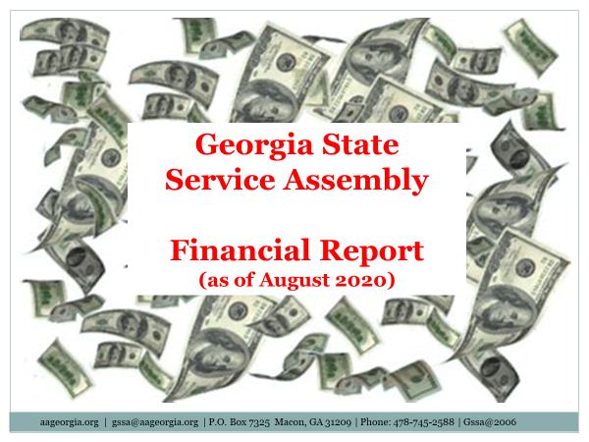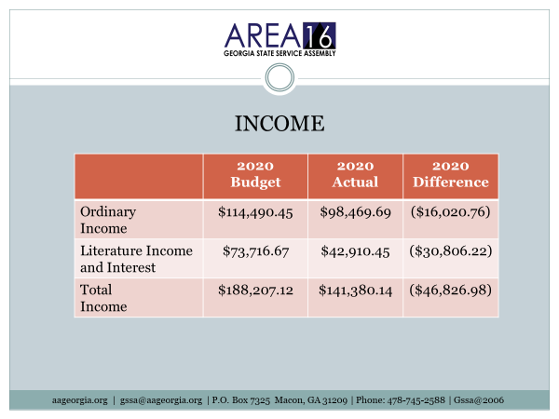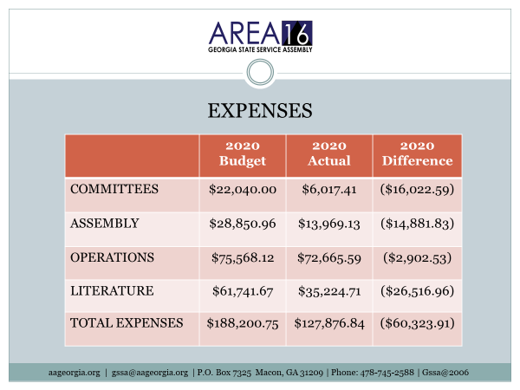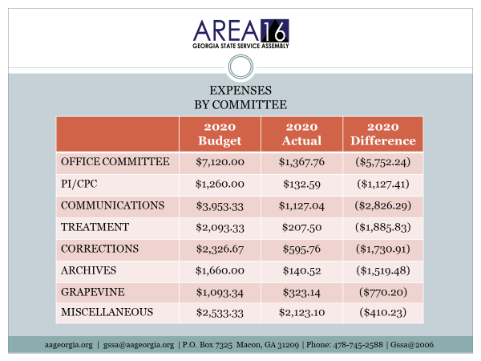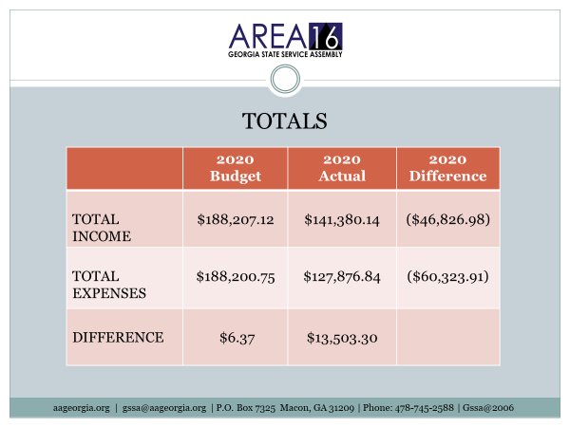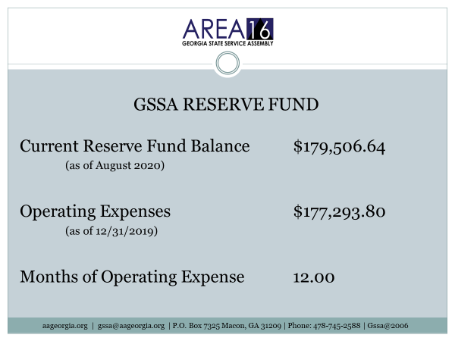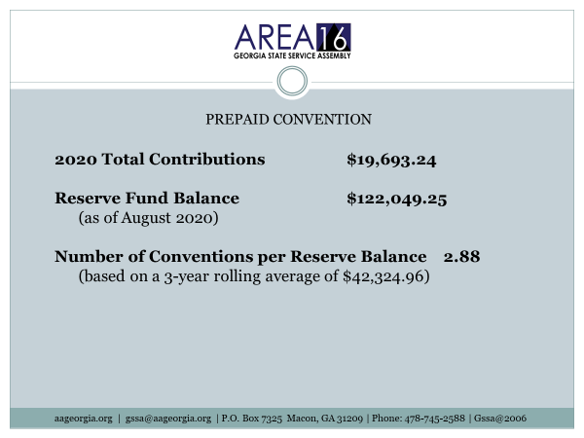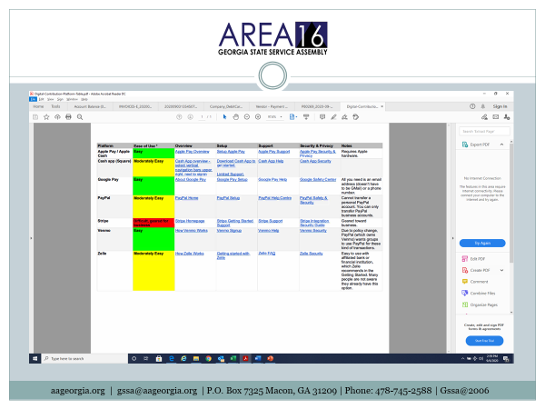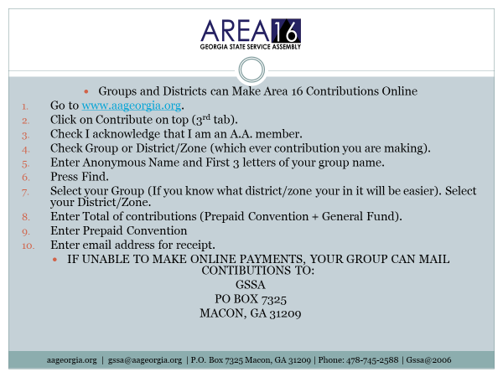

Christy thanked everyone for stepping up and doing a great job helping Area 16 to be able to keep our Prudent Reserve and for their ongoing contributions and for allowing her to serve as your Area 16’s Treasurer. Christy said she was grateful to Alcoholics Anonymous and had always wanted to give back.

Cathy B. Southeast Regional Trustee
Our Big Book
Cathy’s shared the following presentation with us at our Assembly.
There was a motion that came out of the Conference Literature Committee about this presentation. Cathy is on the Literature Committee and the sub-Committee that created this presentation. The presentation will be released later by GSO. It will hopefully be available by the Regional Forums in December.
A subcommittee was formed in a response to a request from the Chair of The General Service Board who had acknowledged that there was a rising number of agenda items from the fellowship regarding the access to our Big Book. What we wanted to do with this presentation was to take all that material that was collected as background for the Agenda Item and organize it into a story. Many of you may have noticed when these kind of Agenda Items are presented, people automatically think that others are trying to change our Big Book. Understandably that notion raises the blood pressure of many of us who have found hope in the pages of this incredible book. The goal of this sub-committee has been to intiate a broader discussion from that simple yes or no option. We don’t expect any answer or total resolution today. Our job is to give all of you enough information to have that informed discussion. It’s not about changing the Big Book but what’s driving all these request. Is there an underlying problem and if so is there a common solution that needs to be addressed.
In order to better understand what’s going on the Committee researched various topics. We reached out to some of the Committees that had submitted motions to gain a deeper understanding of the factors that brought the motion to Conference. We also discussed the original purpose of the Big Book along with the history of the Agenda items pertaining to making it easier to access the Big Book in our Program by the still suffering Alcoholic. A common theme from these conversations was the inability of some to identify with our message.
To better understand why some people are having trouble we reviewed literacy levels along with reading levels. We sought to apply the criteria to the Big Book in order to get an approximation about who can both read and understand the text. There is a huge difference between reading the words on a page and being able to apply the meaning to our lives. Along with the accessablility issue the Committee noted a second driving force. That was relatability. Our Program of recovery depends on the alcoholic being able to self identify. We gathered materials to help determine how our Big Book is meeting that task today.
The concerns about our literature aren’t new. They don’t just involve the Big Book. To round out our review the Committee looked at what has been published so far and help people better understand and relate to the Program including both Conference and non-Conference approved materials. I do want to emphasize this presentation isn’t about changing the Big Book and we aren’t really presenting any answers right now. We aren’t even sure that the Fellowship thinks there is a problem. That’s where you come in. Please allow me to share what we found and then it will be your turn to join in the conversation.
Let’s look first at the original purpose of the Big Book that was published in 1939. Our early members wanting to share their success with the world, wrote down their experience and suggestions for recovery. While the book is an essential tool for working the steps with a sponsor, Bill in his other writings show that it was also meant to be read by that hopeless drunk alone and looking for an answer to escape their alcoholic hell. One quote from we agnostics begins “Lack of Power, that was our dellima” we had to find a Power by which we could live and it had to be a Power greate that ourselves , Obviously! But where and how were we to find this Power? That’s exactly what this book is about. It’s main object is to enable you to find a Power greater than yourself which will solve your problem. This passage really sums up our Program. First the individual needs to identify the problem, lack of power, and then follow it up with the solution, find a Higher Power. I understand that completely. However I can also read at a level that allows me to comprehend most of the words found in the Big Book. The words I don’t understand I can look up and understand the definitions for those words and phrases. That isn’t true for everyone.
Bill wrote in The Language of the Heart about expanding their ability to commiunicate by writing a book about the still small Fellowship story of recovery. Could the written word carry the message? Could the book speak the language of the heart to the drunk who read it? Identification is primary to our attraction to those searching for a solution. When I got sober I had to be able to see myself in the words in the stories written down by our founders and other sober members of this Fellowship. That is the language of the heart. The language that caught the attention of this restless and irritable drunk and planted the seeds of hope. In “Alcoholics Anonymous Comes of Age”, Bill writes that the new book could help indoctrinate newcomers. To me it’s the idea that the book is a tool which could introduce me to the Program. If I needed to look up the work indoctrinate, one meaning is to brainwash, to force someone to accept a particular set of beliefs by repeating the same idea many times so the individual cannot think in an independent way. Here we have an example of what can happen if one simply reads the words and can’t interpret other meanings based on the content of the surrounding text. Later in this presentation we’ll discuss the difference between the reading level and the literacy level. This is a good example of how those with a low literacy level would need to look up words, especially those that may not be in common use anymore.
In this quote from Bill’s notes for the Second Edition he states that the main purpose of the revision was to bring the story section up to date, to portray more adequately a cross section of those who had found help. The audience for this book is people who are coming to Alcoholics Anonymous now. Those who are here have already heard our stories. Since the audience for the book is likely to be newcomers, anything from the view of content or style that might offend or alienate those who are not familiar with the Program should be carefully eliminated.In Bill W.’s writing he consistently recognizes the need to grow and change with the times. Have we listened?
The increasing number of motions from the Fellowship that relate to accessablility and relatability all try to lower the barriers to recovery through the twelve steps. Some want a Big Book with simpler language. Others want workbooks or guides to help members and potential members understand the how to of recovery. Any time there has been a discussion of changing the Big Book or generating aids to help understand the Big Book, the discussions can get both emotional and inspiring. We hear testimonials of those who struggled, not being able to read, being embarrassed to ask for help, overcoming these obstacles and finding a sobriety that changed their lives. In just about any meeting room you can recognize the miracle of recovery that occurs . It is especially moving when the individual has had to humble themselves to ask for that help and to work diligently just to be able to grasp, to identify and then to be able to apply our Program in their every day life.
Often motions to create a fifth edition come with request to update the stories to better reflect the world today or to take out the parts of the book that may sound dated to make the Big Book more relatable. Talk of changing the Big Book upsets a lot of people and rightly so. We who are in the rooms, sober and serene most of the time don’t want to see what got us here, the Program as it is layed out in the Big Book, changed. This was our path to freedom. What of those that couldn’t see the path because they couldn’t read? Maybe there wasn’t anyone who could help them understand the words such as our members in prison or remote areas with very few active sober members. To put it in another way, in another life I wrote computer based training programs for bus operators. At the time there were a ton of instructional programs for driving cars. There just weren’t that many that were specific to bus operators. While the skills are very similar, if the narrator was talking about driving a car the bus driver wouldn’t even listen to what was being conveyed. These individuals didn’t relate to the information because they felt that their jobs were quite different. They didn’t identify as a driver of a car because they drove buses. The instruction or the message was lost. As culture and language have changed there are people that pick up the Big Book and are turned away by the old style, sometimes Christian language, or sexist text. Fortunately I was desperate enough to see past that. Not on my first or second attempt, but eventually desperation gave me an open mind. The reality is that some people die or fail to recover because they have a glaring character defect of being closed minded in some areas of their life. They can’t get past the wrapping to find the present inside. Another relatability factor is due to the changes in language that have occurred. In the 1930’s gender roles were more rigidly defined. Christianity was the more prevalent religion and these realities were expressed in our Big Book. How many of us struggled with the idea that we could find our own Higher Power because the text was greatly influenced by our founder’s own religion? Phrases from How it Works like, “Remember that we deal with alcohol, cunning, baffling, and powerful. Without help it is help it is to much for us. But there is one that has all power. That one is God. May you find him now!” This passage is read at the opening of many meetings. Would it be that far fetched to think a newcomer might conclude that AA was a Christian organization? Gender terms have evolved especially in the last ten years. What started out as LGB is now LGBTQ+ and growing.
To get sober I had to look for the similarities and pay less attention to the differences. Gender terms matter to many, which is evidenced by the number of motions that have been submitted to change the AA Preamble. Some want to shorten it to, We are a Fellowship, others want to change from men and women to people. These request are coming from the Fellowship and our groups from what they are seeing on the front lines of the twelve step work.
Let’s look at some factors that can influence accessability to the Big Book. These include, College education a person has or if they have a reading disabiliy like dislexia, ADHD, or a language processing disorder. Ethnicity can factor in especially when English is not a person’s native language.
We often condiser a person’s reading an invidviduals reading ability when evaluating whether or not they can study the big book. However a better guage is someones’s literacy level. These terms are not synonamous. People who are considered literate aren’t just good readers. They can form meaning from text, think critically about their situation, and apply their comprehension of the text. There are established levels of literacy that can help determine whether an individuals will have dificulty reading and comprehending AA’s message of recovery found in the Big Book. Using these descriptions the Big Book usually falls around a level 3. This means that the reader will be able to arrive a conclusion or decision by reasoning rather than having explicit statements. In AA terms that would to be able to read and translate it into actionable or thought changing ideas. Let’s look at a couple of examples:
There are two main task for the Alcoholic reading the Big Book. The first is to identify with the stories, the way of thinking that is apparent in alcoholics to recognize themselves in the examples. The second is to put the Program as it is layed out to use. The Big Book for these two tasks vascilates between a level 2 and a level 4 but for the most part it’s a solid level 3. In this example the reader needs to identify, am I a real alcoholic and then evaluate if they are deceiving themselves and what behaviours support that conclusion. Are they in denial?
For understanding how to bring our Program into our lives the Big Book is consistantly at a level 3 and sometimes a level 4. In this example the reader needs to pick out the reason and conclude that this is the way to stay sober. We have to be humbled and willing to look at ourselves honestly, which I would venture to say was not that easy for many of us. Using and example which applies the ability to apply background knowledge as well as interpret or evaluate broad truth claims or arguments which bring it up to a level 4. If we rest on our laurels the suttle foe of alcoholism will win out. We get a daily reprieve contigent on the maintenance of our spriritual condition. I love those words. They give me solid direction that I need to be persistant in my recovery and not complacent. For others the words and phrases may be difficult to parse out the meaning. With and average level 3 rating, what does that look like in terms of people who can read and understand the Big Book. In general across the United States a little under half the people can read at a level 3 literacy or above. If we look at College graduates in the U.S. that number goes up to almost three quarters of the people can read at a level 3 or above. When we consider the other side of the educational spectrum those with less than a high school diploma, only 17 percent of these individuals can read and understand the Program as it is laid out in the Big Book. That is less than one fifth of the people without a high school diploma. What about another group in our membership, those members that are incarcerated. How do they fare? Looking at the prison population across the educational spectrum, the alcoholic in prison will be less likely than the general population to access the Program’s message of recovery. That is true in almost every category.
Recognizing the fact that many people may have difficulty reading, the Fellowship has requested pamphlets and other materials over the years. Examples would be the comic book style directed at the young people, and the easy to read version of pamphlets such as the Steps, the Traditions, and the Concepts illistrated. AA literature that addresses relatability factor have also driven Conference Motions. These include pamphlets directed at those who are atheist and agnostic women and other cultures. In addition the AA Grapevine is often noted as carrying our message using modern language and acknowledging various populations such as LBGTQ, Black and African American alcoholics and our members behind bars. Outside of AA and the Grapevine other publishers have stepped in to provide simple language versions or modern language that degenderize or secularize the text. Workbook and step guides that include worksheets or are focused on populations like women or young people. Many use these alternative materials to study our program.
The big question is, how well do these documents explain and stay true to the Program and the principles of Alcoholics Anonymous. One of the earliest of these kinds of tools were a set of pamphlets known as the Akron Pamphlets which were actually requested by Dr Bob. The first was called “A Manual for Alcoholics Anonymous. It is said that Dr. Bob felt that the language in the Big Book might be a little high browed for the average alcoholic. To ensure that more people could understand our message he commisioned Evan W. to write a simpler guide that groups could give to the newcomer. The forward to the pamphlet states this booklet is intended to be a practical guide for new members and sponsors of new members of Alcoholics Anonymous. Basically it is a tool to help both sponsors and sponsees navigate the Big Book. It’s interesting that there was a passage to the ladies in the first Akron pamphlet which compares to our current addendums to our Big Book that explain any outdated language. The note states in part, “we merely use the masculine pronouns he and him for convenience. We fully realize shows no partiality. Every word in this booklet applies to Women as well as men.
Our founders have been credited with great forsight. They recognized the nature of the alcoholic and wrote a text that would best speak to the still suffering individual at that time in history. Let me end this presentation with a quote from one of Bill’s Conference talks. “We live in an Era of change. Our twelve steps probably won’t change. The Traditions not at all likely. Our manner of communication, our manner of organizing ourselves for function for service, let us hope that this goes on changing for the better forever. There is a very natural resistance that we have towards change. We are apt to say, well it worked very well the way it was why change. So now it is up to you the Fellowship to help us have that discussion and answer that question.
Here are some questions to consider:
Should the Trustee’s Literature Committee explore possible solution…inaudible…. If so what other information would be helpful to determine if additional items are needed to increase the accessability and the relatability to the AA Program?
Would a translation into modern or simpler language help?
What tools would help others understand our Program of recovery? Workbooks? Dictionaries?
Thank you for giving me the time today to share what the Sub-Committee put together and some of our research and discussions. I do hope that it has been helpful and that it will initiate a larger conversation about this topic.

Rick Thanked Cathy for being with us and for her Presentation.

Past Area Officers Were Recognized

Old Business
Proxy voting was reintroduced due to proper procedure.
Rick-As your Chair, my job is to keep the meeting moving. The objective of following Robert’s Rules of Order for us in the Assembly is really to proceed in an informal basis consistent with the rights of everbody concerned. It is about the body approving business here in front of us. But there are occasions, the proxy vote being one of them, where the Chair has a procedure to put forth a motion. It does require a second from a GSR. In this case I am asking that we suspend some of the guidelines we have in place for the betterment of this particular meeting only. The way that works is that I’m putting forth the motion to suspend the voting guideline of proxy votes not being accepted in accordance with our manual. It needs to be seconded by a GSR or voting Alternate GSR. It’s not debatable. It can’t be reconsidered. It requires a two thirds vote.
Again the Motion to suspend the voting guideline of proxy votes not being accepted in accordance with our manual so that the group that is unable to vote is able to. I need a second from a GSR.
There were some technical difficulties at this point with who could hear, speak, and or vote. This was resolved and we moved forward.

Meaghan G. 14D GSR Paulding County Group seconded the motion.
Voting Poll was attempted again. (Some that were trying to vote got a fail)
Rick asked how many people are in the voting room. 75 in non voter room. 186 in the main (voting) room including co-host. Zoom does not allow Co-Host to vote.
Voting Poll : Allow Proxy Voting for this Assembly only. (Poll launched again)
Christy and Harold confirmed the results as follows:
152 voted. 102 are required for two thirds
142 yes
10 no
Proxy vote will be allowed for this Assembly.

Approval of Business Meeting Minutes from May 2020 Assembly
Poll launched
144 yes . We needed a majority and we got it. Minutes Approved.

Dublin 2021 Assembly location update
Ernie M. – Area 16 Office Chair

The OFTC DuBose Porter Center
The GPS address is
560 Pine Hill Rd
Dublin, GA 31021
Directions:
Coming from Macon take interstate 16 to exit 51.
(US319S/US441S) bear right as you come off I16 to Pinehill Rd
From Savannah take Interstate 16 West to exit 51, (US-319S/Us441S) take left onto 441 and follow across I-16 to Pinehill RD. This will lead you to the Dubose Porter Center. (OTC)
- As you come off I16 or across I16 look to your right and you will see gas station. Turn into entrance for gas station and follow road around to right and it will lead you to the Hampton Inn & Suites. This is the main hotel hosting our Area Assembly. ​
- Hampton Inn & Suites: Tele # 1-478-246-6055​
- Reservations under “GSSA Organization” ​
- Contact – Melanie Patel, Director of Sales​
- (478) 246-6055 or (478) 246-6955​

Hotel Information
Phone Number 478-246-6055

Room Rates: Standard QQ or KG = $119 +$5.00+$9.52 = $143.04​
Free hot breakfast. (6AM – 10AM) ​
Free highspeed and wireless internet (access all guest rooms & lobby

Free parking. ​
Walking path to Dubose Center (OTC) from Hotel. ​
Convenient eating facilities – Huddle House, Cracker Barrel, Longhorns, ​
Zaxby’s – withing walking distance from hotel. ​

- Hampton Inn & Suites will take our reservations up to four (4) weeks out. Reservations, if available, can be made up to week of Assembly. If overflow is needed you will be directed to the La Quinta right next door and at the same reservation rates. ​
- ​
Thanks for allowing me to serve. ​
Ernie M. Area 16​
Office Committee Chairperson​

HOW THE ASSEMBLY OPERATES, AMENDING MOTIONS, CALLING THE QUESTION, and MINORITY OPINION were read.

Motion: I move that the Cluster Forums be returned to Eight beginning in the 2021 calendar year.
Discussion:
Karen A., DCM 11B- We are just coming out of this Pandemic or are still in this Pandemic. We discussed our budget earlier yesterday; would these Cluster Forums being drawn out when we are not sure what our situation is going to be. I would think that this may be a premature decision and may be something that should be tabled. Just a thought for consideration.

Phil S. GSR 16C- Since this was pushed back in May and we are pretty much in the same reason, we can’t get any more Cluster Forums when we’re having to cancel the ones we’ve got. We could continue to table and push down the line but if we just vote on this (and I’m assuming that it would probably be to not do this) when could it be re-introduced as an idea if next year things are looking better and we’re thinking maybe we can do eight now when our budget’s good. How long would it be before that motion could be re-introduced to go to eight?
Rick- That’s a good question. If it is tabled normally it gets pushed to the next Assembly and is addressed.
Elaine P. – I have a suggestion that we make the Cluster Forums virtual because I think we’ve been able to reach a lot of people with virtual methods. Not that we should make that the only form but in light of the Pandemic that we consider virtual Cluster Forums.
Bill M., Past Area Treasurer-This whole thing to go from 8 Cluster Forums to 4 was a budgetary consideration. We just had a Treasurer’s report that the budget is in good shape. We have money coming in as necessary which Georgia has always done. I don’t want to have Cluster Forums if we are going to go and get somebody sick. The Office Committee can cancel these things as necessary. The Cluster Forums are one of the great vehicles over the years to get the word out about what Business Georgia AA is doing out to the masses so when the Corona thing goes away there is no reason why we shouldn’t be having them. The budget is no longer the consideration. We’ve got the money to do that. I think it was premature to cancel a lot of these things because of budget considerations in the first place. There is no reason not to go ahead and approve this resolution and then cancel if you have to.
Rusty L., Alternate DCM 13A- I wanted to address the other part of Phil’s question about if it was voted down, correct me if I’m wrong, don’t we have a small t Tradition about not bringing up motions for 2 years if they are voted down. It may not be written in stone but I remember discussion about that in the past specifically concerning our next motion which is Electronic Voting. If someone could expand on that. Having just heard Bill’s comments I agree with him that we have the money right now but looking at the budget based on the numbers we have to use to calculate projected income and expenses I don’t think allow for 8 Cluster Forums without erasing some other things in order to do that. Thank you.
Rick- I don’t want to comment on whether it can be brought up again because I think that’s getting off into what if…. I think we need to stay with the topic at hand right now which is this motion to be done in 2021 that hasn’t even passed yet.
Mitch M., 7B Treasurer- I would rather stay at 4 Cluster Forums and see Workshops, whether it be Treatment, Corrections, Archives and others from the Your Voice Matters Action Plan. The workshops are a lot less expensive than the Cluster Forums. Thanks
John S. DCM 13B-The only thing we need to discuss today as a body is whether we want to return to 8 or not. That what the Motion is about. Any other considerations will be handled as necessary whether budgetary or Corona Virus as we go along.
Kim J., DCM 12A- Considering not knowing what is going to happen is there anything to say that we can’t have all 8 and have them virtually.

Motion: I move that the Cluster Forums be returned to Eight beginning in the 2021 calendar year.

Voting

Total number of votes. 149
We needed 100 votes for two thirds.
Yes 56
No 93
Motion did not pass.

Minority Opinion

Phil S. 16C, GSR Serenity by the Sea- I voted to adopt the motion. At first, I said I would vote it down because of the current condition. When Bill brought up that this was a budgetary issue of can we afford to go back to 8 and the answer is yes. That totally changed my mind.
Elaine P. With these Cluster Forums we could reach the people that are unable to come to the Assembly. I think we are doing a disservice to them.
Rick- I would remind everyone that only voting members can share a Minority Opinion.
Cathy A., GSR 14B- Cluster Forums are very important. I’m all about expecting things to come around eventually. I think we need to have 8. Especially when we can do them virtually. When we do get back, we will have already voted on having the 8. That’s just a personal opinion. I’m tired of living like we don’t have a tomorrow.
Ernie- Rick, point of order. Since the Motion reads, “to be returned to 8 Cluster Forums, that in order to pass would have to have two thirds majority, is that correct?
Rick-That is correct.
Ernie- It did not get it so the motion failed. That is answering Amy B’s question from the chat.
Sharon P. GSR-I have been trying to get back in for 30 minutes now. There is no way to get a hold of somebody. I chatted; I’ve sent my Alternate a message. I’m still not in.
Rick-I am hearing that you are having a possible problem with your connection. Paul did you hear the same thing.
Paul- Yes. Sharon if you will contact myself or Dave at webcommittee@aageorgia.org we will help you so that this doesn’t happen again. We are sorry for the technical difficulties.

Motion: I make a motion that we move to electronic voting for GSSA elections.
Discussion
Claire P., GSR, I Am Responsible Group, District 8-My group had questions about fees associated with electronic voting.
Rick- Our Ad Hoc Committee talked about different suppliers and vendors to assist with electronic voting. Right now, we are looking at whether to go ahead with that. If the motion were to pass, we would then move forward as to how we would go about doing electronic voting for GSSA elections. You can refer to the Message where the Ad Hoc Committee gave their full report in September.
Celeste GSR Pembroke District 5A-My group wanted to make sure that this is electronic voting for in person Assembly and nothing to do with any of this Zoom stuff. Is that correct?
Rick-That is a good question. Right now, the motion simply states: I make a motion that we move to electronic voting for GSSA elections. It does not specify whether it is at a Zoom environment or in person.
Katy I. Alternate DCM-If this were voted in then that would also allow Zoom voting. Is that correct?
Rick-We don’t know if possibly that would be the platform used if the motion passed.
Katy I.-So Zoom would be included in that possibility.
Rick-I guess you could say it’s possible.
Katy-There is an expense if we go to the hand held. There is not a whole lot of expense with Zoom. Is that correct?
Rick-A whole lot of is a very open-ended statement. That is a good point you make about the various types of voting.
Phil S. GSR, 16C-I am a big proponent of electronic voting. Obviously when this motion was proposed back in September there was no knowing to account for this type of electronic voting that we are now doing because we are forced to. At the time we were strictly talking about in person because that’s all there was. The Committee that went out to investigate it came back with information about different ways to do it. They did not give a recommendation. They did not give a price of what we should do. The goal of this vote was to say that we are going to do electronic voting. Not that we are going to do it in this way that’s going to cost this much money. That we have done it twice over Zoom shows that it is possible. The question is when we go back in person are, we going to be doing electronic verses the paper ballot which obviously we are talking about not doing that because of how long it takes. I wanted to talk about this at the last Assembly but didn’t get a chance to. There are less expensive ways to do it. This is not a motion to spend money that has a price tag on it.
Nancy N. GSR 7B- Was there a study to see if there was a difference between the number that were supposed to vote and the actual number that vote? I noticed in the last election we had that there was about 21 people more than the number of eligible voters were read by the Secretary in Attendance. It was a pretty significant difference. With Electronic one of the points is to get that accuracy. I think that sometimes members in general sometimes get caught up when it gets exciting during the voting and people raise their hand when sometimes they may not be eligible to vote. I was wondering if the Committee had considered that.
Rick- That’s a great question and I will put that out there to anybody here right now that was a member of that Committee.
Paul-Please raise your hand if you were a member of that Committee.
Rick-The Committee did a lot research and brought that information back in their Report. There does not appear to be anyone here from that Committee.
Daniel L., DCM 16E- We are doing Electronic voting now out of necessity. For the last two maybe three it’s been a one maybe two deal where we’ve been able to get through them fairly quickly. With the way financials are looking and the way money is being spent is this really a solid avenue to have expenditures for voting so we can just get out quicker. We all volunteered to be here and that’s really part of the gig. Paul you are doing an amazing job!
Chris M., Member at large 1A- I was actually on that Ad Hoc Committee and would like to take the question again.
Rick- I can paraphrase it. Basically, what did you look at in terms of the types of voting and was Zoom part of that?
Chris M.- Zoom was not a part of it. Zoom was not even on our radar. We looked at several ways of voting. The main one was hand held devices called clickers. That way Internet, or phone service, or laptop or WI fi would not be an issue for those who wanted to vote. But we did also look at those options as well. Clickers and voting by internet were both researched.
Peter M. GSR 12A- This is going to cost money. Spending the money to make one Assembly a year shorter is not a useful way to spend our resources.
Denny M. 5C GSR DDLC Group- Call the question so we can get to the vote.
Rick-Calling the question is without comment. Next please.
Rusty L. Alternate DCM 13A- It doesn’t seem that Zoom is appropriate other than a virtual setting. It is appropriate in a virtual setting. In the in person setting we would have to stop and have all the voters log in to Zoom accounts and then try to vote. There are other electronic ways that were discussed by the Committee that are options.
Motion: I make a motion that we move to electronic voting for GSSA elections.
Voting:
Christy 98 votes would be required for a two thirds majority.
146 voted
Yes 86
No 60
The motion does not pass.

Minority Opinion
Phil S., GSR Serenity by the River Group, 16C – People that voted against this, it seemed because of finances and I wanted to be clear that this is not about money. If we were to moved forward with electronic voting, we could then decide about the cost moving forward. This would be about moving into the future with the accuracy of knowing that the people that were voting were supposed to be voting.
Adam M. 13H GSR One Breath at a Time Group-The electronic voting is an efficiency and an accuracy. This would allow us to get to more business. Coming from an IT background there are more ways to do this and especially insuring that only people eligible would vote.

2022 Area 16 Prepaid Convention

District 12 Bid for 2022 Georgia Pre-Paid Convention in Augusta, GA
Kim J, DCM District 12a

Dates: Friday Oct 21, 2022 with registration beginning at noon through Sunday Oct 23, 2022

Location: Marriott Convention Center, Augusta GA

Anticipated attendance: 1200
Room Rates:
$165.76 including current taxes, fees, parking ($134 room rate w/o taxes/fees)
Meeting Space:
$5400, assuming 85% guest-room pickup rate
Coffee:
$7576 based on 2016 usage of 115 gallons of coffee at $50/gal ($65.88 including taxes)
Dinner Sat night:
$11,859 assuming 300 attendeesat$30/person ($39.53 w/fees)
Staging:
$250
Wi-Fi:
$118.58
Banner hanging:
$50
Exhibit table setup:
$300
For a total of: $26,000 (rounded)

Other hotels in the area range from $91 to $103 (not including taxes and fees)
Variety of restaurants in the area
Attractions include: Golf, Augusta Canal, Riverwalk, Phinizy Swamp Nature Park, Savannah Rapids Park, Art District, Clarks Hill (Strom Thurmond) Lake

Dublin Bid 2022 Prepaid Convention

THINGS ARE GREAT IN DISTRICT EIGHT
October 21-23, 2022
Amy B.
Where progress is perfection.
- Geographic center of Georgia
- Direct access to I-16, Hwy 441, and US 80
- 5 national chain hotels within walking distance of conference center by a walking trail.
- 9 additional lodging options 2 minutes away.
- Rates $69-$139 per night.
- Minimum of 10 comp rooms for State Office Committee, Convention Chair, Co-Chair and all Speakers provided by Visit Dublin DVB.
Play in Dublin
- Haunted Montrose
- Pumpkin Patch & Farmers Market
- Golf Riverview
- Movies at Martin Movie House
- Downtown History Tours
- Monster Dash Fun Run, 3K, & 5K
- Kayak the Oconee
DuBose Porter Center
Training Rooms
- Over 17,000 sq. ft.
- Flexible hall configurations
- Conference Center exhibit hall can be divided into as many as eight individual rooms.
Lecture Hall
- 120 seat lecture hall features tiered seating
Classrooms
- Six general purpose rooms to accommodate 15-40 persons
- Flexible seating arrangements (classroom, theater, U-shape, or boardroom style) customize for your group meetings
Board Room
- Seats 12
Livingston Hall
- Additional 10,000 square feet meeting space
Facility Rental
Food minimum/catering: n/a
Coffee: 83 urns (124.5 gallons @ $30/urn-30 8 oz cups) =$2490 (2490 cups; $20/gal)
Audio-visual: $100(mic rental)-everything else is waived
Security/Medical Personnel Not required per city of Dublin ordinance
Large Meeting Room Setup Waived
Additional Meeting Rooms: $0
Internet Access Included
Total Facility Cost $9,401.00
SEE YOU IN DUBLIN!

Vote
147 voted
Augusta 57
Dublin 90
The 2022 Prepaid Convention is awarded to Dublin. (a simple majority required)

Approval of Trustee Candidates

Ernie M. Office Chair- The qualifications for Trustee

Area 16 S.E. Trustee Candidate Tom H.
Vote
137 Voted
Approval 135
No 2

Area 16 Trustee-at-Large Candidate​ Rick M.​
Vote
145 Voted
Approval 140
No 5

We Congratulate our new Trustee Candidates.

New Business

Approval- Area 16 use of 2021 General Service Conference theme and workshop titles for the 2021 Cluster Forums.
Vote
145 Voted
Yes 137
No 8
Approved

Elections for Secretary and Treasurer
Third Legacy voting procedure was explained from the service manual.

Qualifications for Secretary Area 16 were read
1st Vote
Ashley M. 59
Liz W. 81
94 needed for two thirds

2nd Vote
Ashley M. 52
Liz W. 94
98 needed for two thirds

3rd Vote
Ashley M. 36
Liz W. 114
100 needed for two thirds
Liz W. is our new Area 16 Secretary
Thank you, Ashley M., for standing.

Qualifications for State Treasurer were read

Vote
Kelly G. 104
Dorman P. 37
94 Votes needed for two thirds.
Kelly G. is our new Area 16 Treasurer
Thank you, Dorman P., for standing

General Sharing
Amy S. GSR Greenhouse Group, Norcross-
Motion
I make a motion to change our Grapevine Committee name to the Grapevine/Lavina Committee in line with the 70th GSC Advisory Action.
Kathie A., GSR 14B seconded the Motion

Discussion
Amy S.- Grapevine and Lavina need to be together. I believe we should support Lavina.
Harold C., 16B, We Can Relate Group- I would like to call the question
Rick-Calling the question requires a second.
Susan G. GSR 7A Surrender Group, I second
Rick-This is not debatable and requires two thirds vote
Due to technology restraints I recommendation that perhaps what we do is that we table this motion to the next Assembly
Anna M. I make a motion that we table
Brook B. 2B GSR Back to Basics- I second that.
Yes or No was voted through the Participants.
Yes was the majority vote
Tabled till the January Assembly

Rick-Now we will have General Sharing.
Rusty L. Alternate DCM 13A- Thanked Paul and our Web Committee for all their work to put the Assembly together.
Bill M. Past Area Treasurer- This was a Manual change (the motion on changing the name of the Grapevine Committee) and would require it be tabled and a Ad Hoc Committee be appointed by the Delegate to bring a report to the next Assembly. With this Zoom there’s no way for somebody to say Point of Order and get it back like it is supposed to be. You did it right quite by accident with a lot of confusion. We had that problem and the question came up about this if something has been defeated two years before it can’t be brought up again. All that was because of some bad decisions made by the Chair. I think the answer is in the book and the book says an automatic tabling and we can move on.
Chris S. GSR Get Real Group- I would like to reconsider Electronic Voting.
Rick-We are beyond that at this time. Thank you.
Brook B. 2B GSR Back to Basics Group- Makes the following motion:
Motion:
I make a motion that page 13 of The Georgia State Service Manual be amended as follows:
On page 13, under the heading of “Changing the Guidelines in the Georgia AA Service Manual” the following be added:
In the event such motion fails to receive a two-thirds majority, a subsequent motion, having the same or similar substance, shall not be allowed for a period of 5 years.
Bill H. GSR 2B As We Recover Group- I second the motion.
Discussion
Brook B.-My rational is that once we vote something down by two-thirds that it not be brought up every singe time at every single Assembly. Once we vote it down let there be a time frame before we bring it back up.
Tom H.-Applaud to the Office Committee and Technical Committee. No where in our fellowship will you find this, not at Conference, not anywhere. What should happen is the vetting of the Motion at Assembly. When someone makes a motion and there is a second and it’s a Manual change, we are automatically required to go through 3 Assemblies. Those two people, the motion maker and the second control part of the Assembly with an Ad Hoc Committee for the next couple of Assemblies. What should happen is almost like with calling the question. Just because we call the question doesn’t mean that we stop and vote on the matter. It requires a second and it requires a majority vote in order for us to end discussion and go straight to a vote. That would be a better motion is that we should have a motion to the Assembly that do you guys want to talk about this for the next 3 Assemblies. Then the Assembly body gets to weigh in and say yes or no. That would kill the over and over again. That would solve this problem in a much better fashion instead of a good motion that barely fails and now we can’t talk about it for 5 years. This does not happen at Conference.
Brandon L., DCM 7A- When this motion was brought up recently it was about Electronic Voting, we found that it had been voted on in 2017 and enough time had passed. I thought that there was something already in place to that effect however I could be mistaken.
Marshall C. GSR Northside Young People-I was under the impression that some people wanted to make a motion to reconsider the electronic voting question. They posted in the group chat instead of unmuting and weren’t quite clear as to when the proper time to do that was.
Rick-Right now we are talking about the motion on the floor. You can bring this up in General Sharing.
Peter M., GSR 12A, National Hills-Instead of not allowing motions to come back to the floor we really need to look at some type of vetting process before motions get introduced that take up a considerable amount of time and energy.
David S. Past Area 16 Delegate Panel 56-There has been a lot of chat going on in the background. There seems to be some understanding that there is some of moratorium preventing a topic from being presented in consecutive or two-year time frame. There is no such moratorium. A topic can be brought up over and over. Whether or not that is a good thing is apparently going to be up for discussion coming up in January as well as now. I just want to clarify that there is not now nor has there ever been anything in writing that says a topic once defeated is prevented from being brought up again. That’s not only at our Assembly it also applies to The General Service Conference. Second thought, the possibility of having motions vetted. Not such a good idea. Who’s going to vet them? Is it going to be a Committee? You are talking with that particular idea, trying to prevent a group from presenting their ideas through their GSR regardless of what they are. The main point there is no such moratorium.
Joan Mc., Alternate GSR, Chapter 3- Can the person who made the motion are they willing to change it to the thought that Tom had of bringing to the body to vote if you want to hear this or do you not want to hear it? Verses having an Ad Hoc Committee look into this.
Rick-Thanks for the comment. Usually amending a motion involves a word or words and not the entire motion.
Rick-This will be turned over to our Delegate. It is automatically tabled, as it is a manual change. I appreciate all the comments and help on this. Now we go back to General Sharing.
Denny M., GSR DDLC Group, 5C-Motion to adjourn.
Rick-Thank you Denny. We have had several motions and one share. I would like to allow a few more people to have an open sharing.
Phil S., GSR 16C-This is both about the Cluster Forum thing and the Electronic Voting. For both of those we had minority votes and then immediately after we had the Minority discussion we moved on and there were people in the chat going wait, wait, I wanted to change my vote, why aren’t we doing this? Then someone answered in the chat that the way it works is that once you have the minority voice, someone from the Majority needs to make a motion to revisit or reconsider. People in the chat were saying well I didn’t understand that. They were there. They were right there. They wanted to reconsider. They wanted to have the motion reconsidered at that time. I feel like we are being very patient with how difficult and confusing this is with a lot of matters but with other matters we are not being quite as patient. I think this is one situation where we are not being quite as patient. There are people here who would like to reconsider a vote. Especially the one on Electronic voting that was very close. It was a win; it just wasn’t two thirds. I think we moved a little too fast there and people didn’t understand. I would like that to be addressed and give people the opportunity to voice that. It’s going way better than it could be. You guys are doing an awesome job.
Rick-That’s a great point. As a Chair I don’t say anything at that point. There is a pause and then you would raise your hand after the minority opinion. You have a good point. As an Office Committee, we need to discuss that with an eye towards this technology and how we do that.
Beth S., 11B Archive Chair, Women in the Mirror-This is a first time for me in a lot of different ways. Our Group, Women in the Mirror just voted to become a group on September the 12th. My GSR and my Alternate GSR are both here. This has been incredible. We are on such a huge learning curve right now. Technology has to become our friend. As someone who is in my 60’s I’m on the tail end of learning this technology thing. I want to thank everyone for their warm welcome for our Group and for the opportunity to be of Service.
Chris S., GSR 7A Get Real Group-Motion to adjourn.
Dan U. GSR First Things First, 3A- I second the Motion.

Meeting Closed with the Responsibility Statement

.

.

